**ASSIGNMENT – 4**

**DOCKER AND KUBERNETES**

|  |  |
| --- | --- |
| Date | 2022-10-31 |
| Team ID | PNT2022TMID31927 |
| Project Name | Project – Inventory Management system for retailers |
| Team Members | Kartheepan. D  HariKrishna. P  HariharaSudhan. I  Logesh. S |

Question-1: pull an image from docker hub and run it in docker playground.

1) pull an image form docker hub

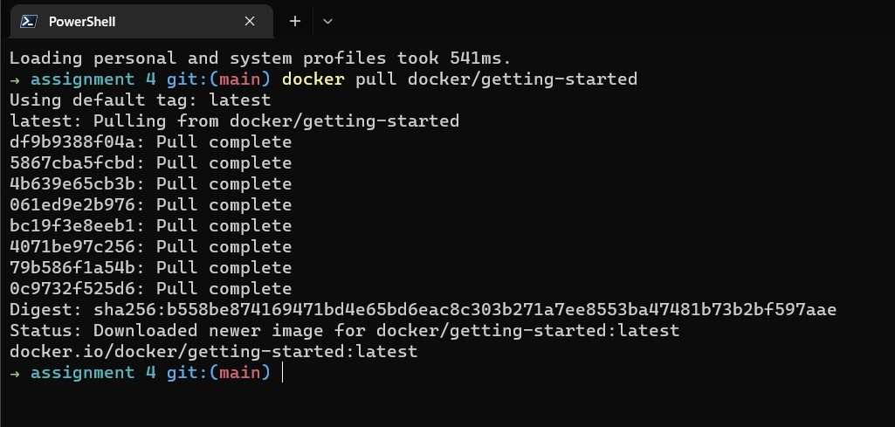

2)runt it in docker playground

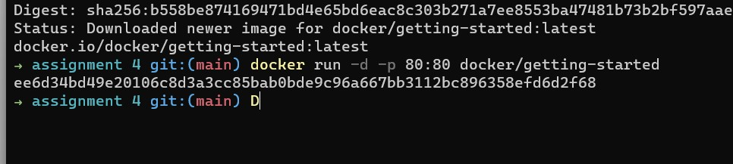

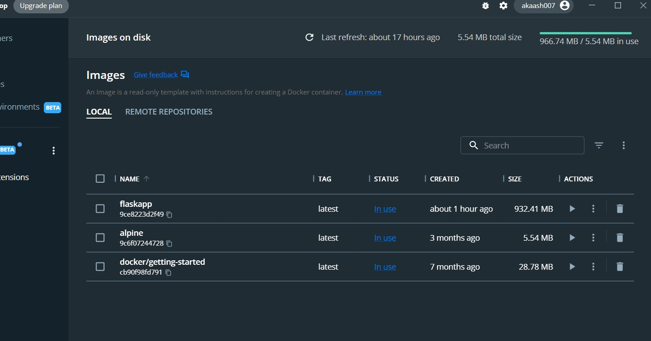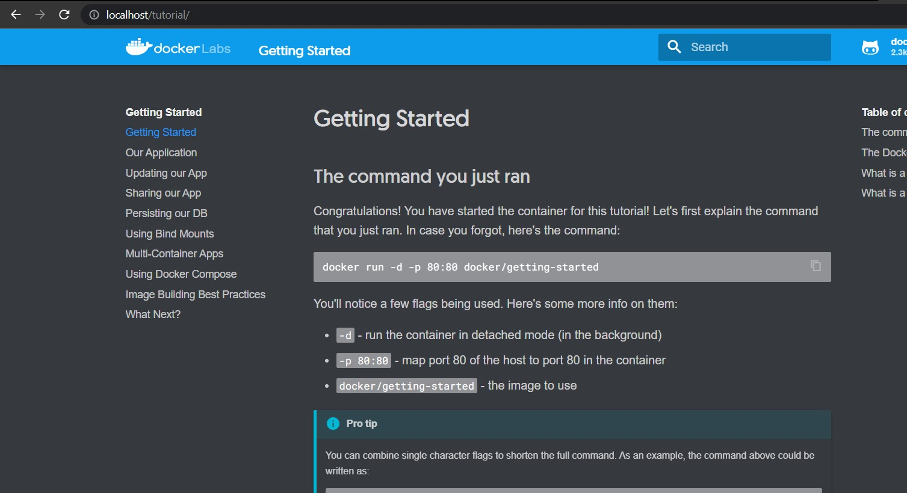

Question-2: Create a docker file for the job portal application and deploy it in docker application. 1)Creating a docker file for the job portal application

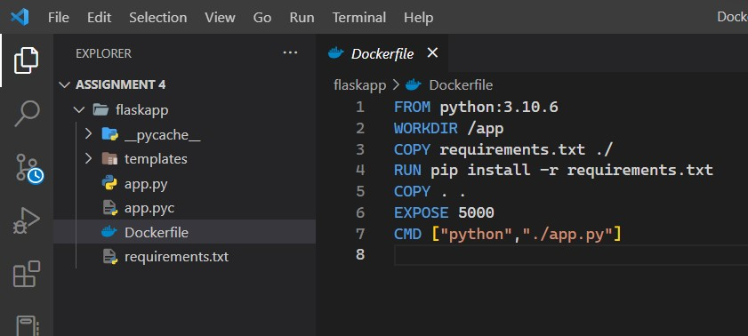

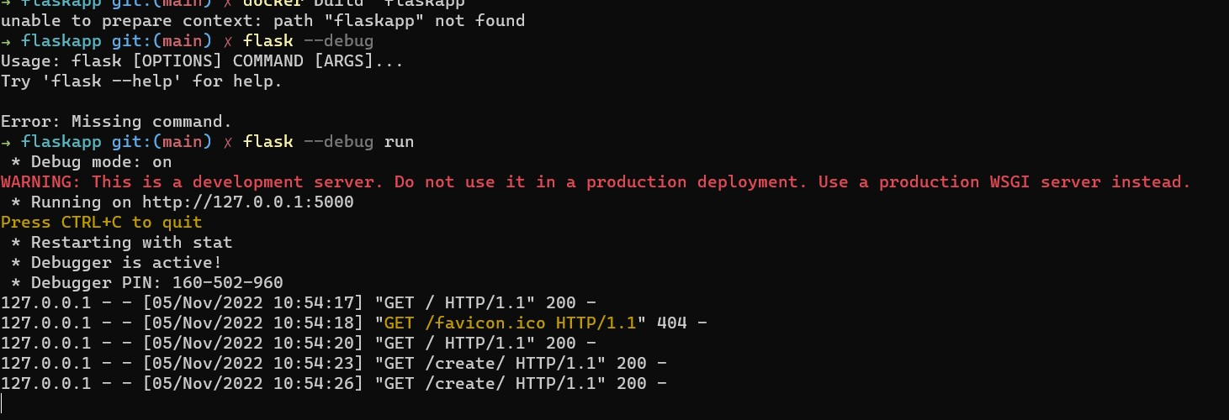

2)deploy in in docker application

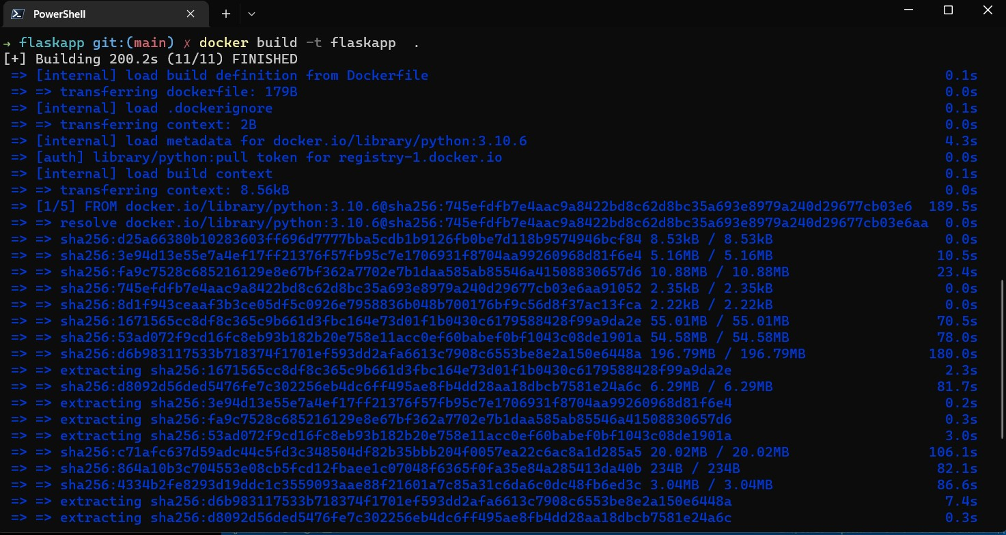

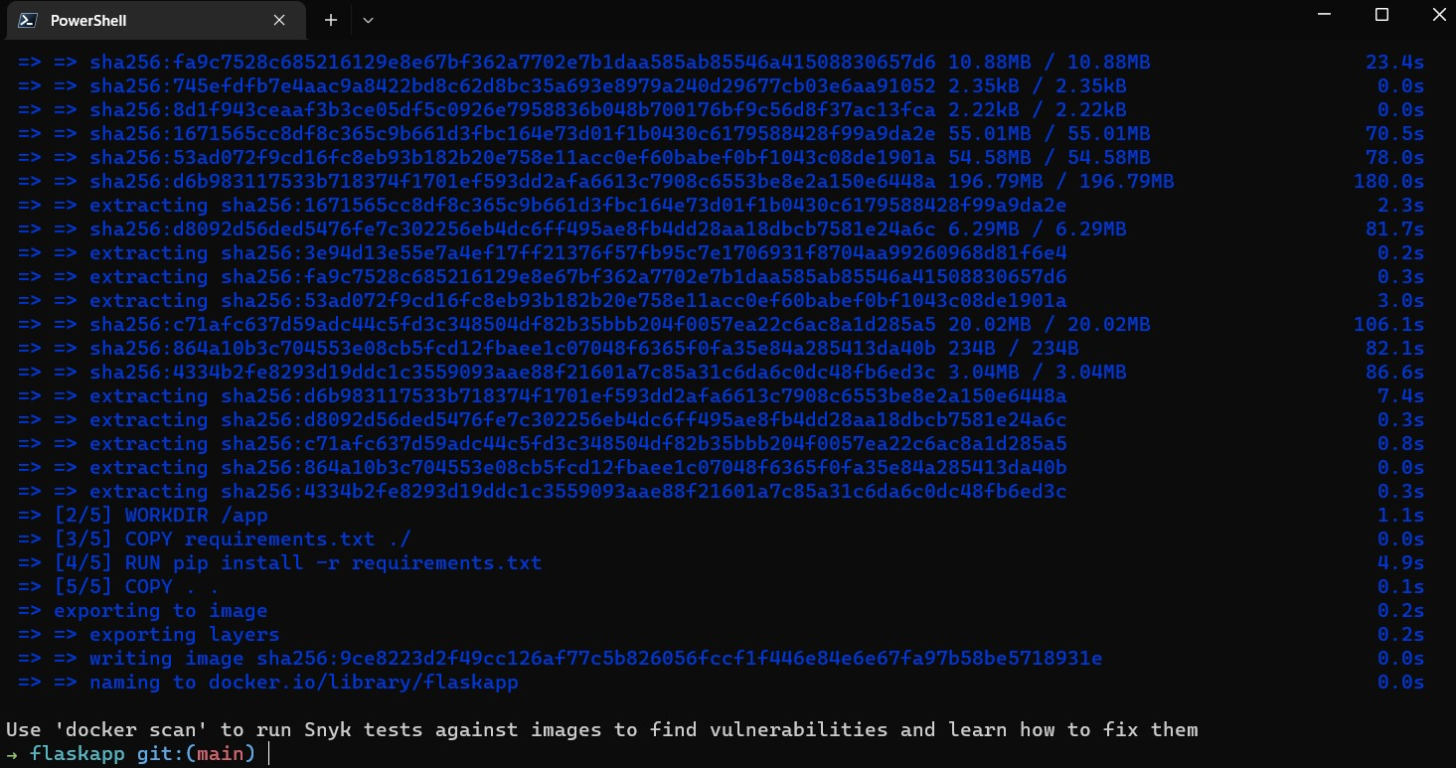

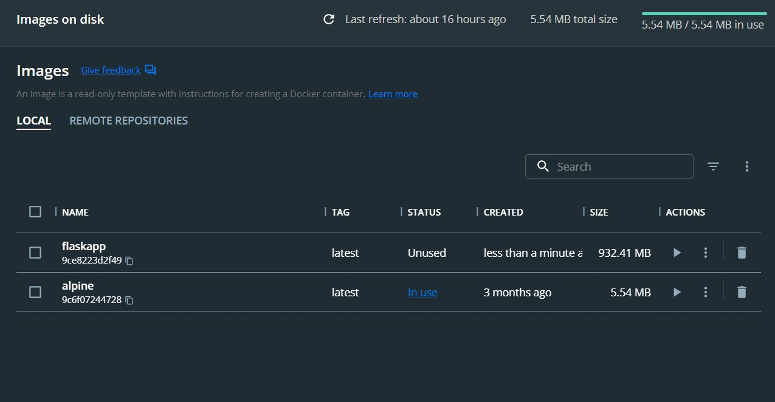

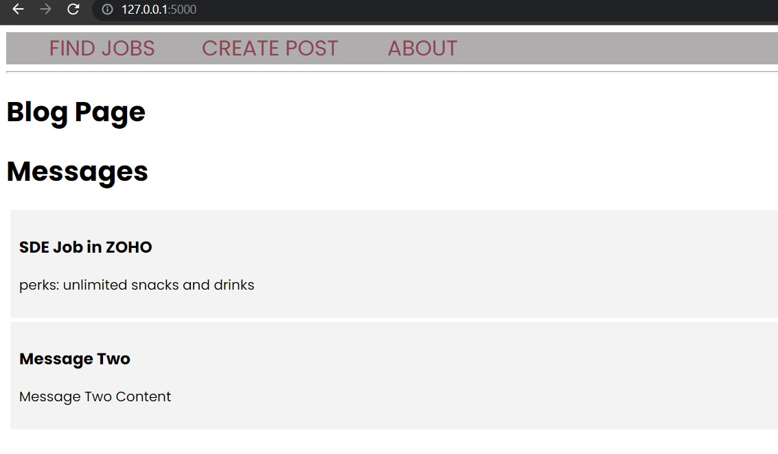

Question-3:Create a IBM container registry and deploy hello world app or jobportalapp 1) create a IBM container registry

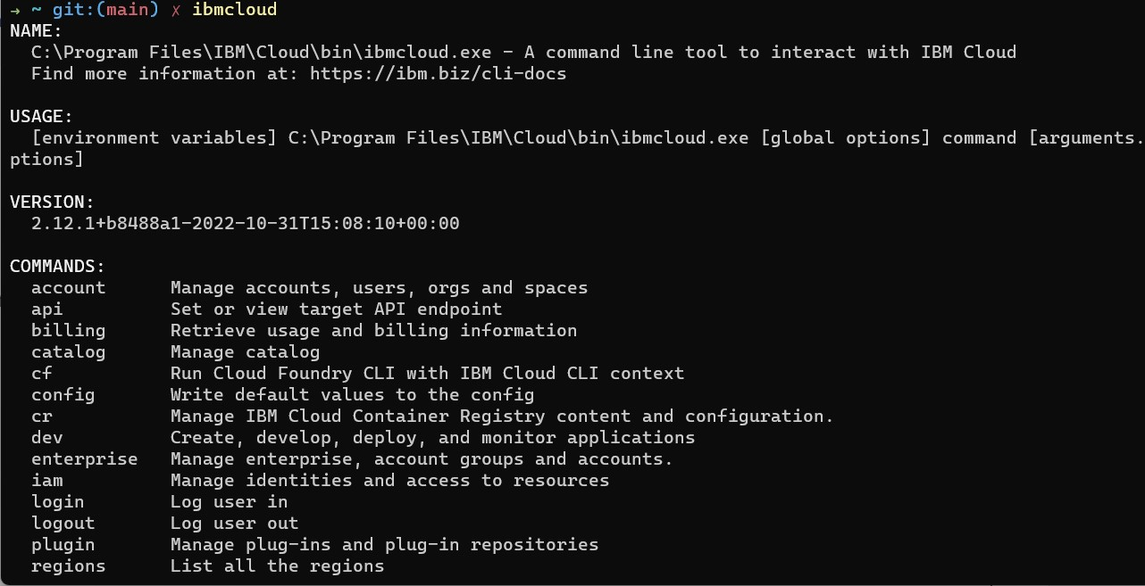

2)deploy hello world or jobportal

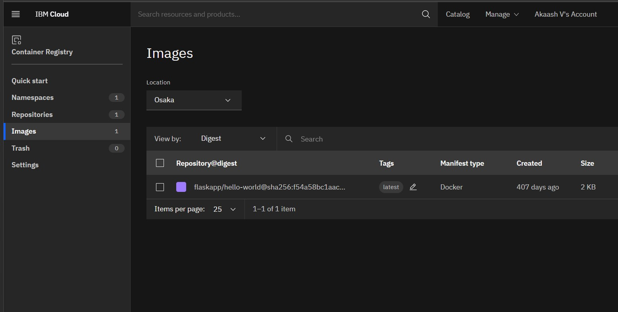

Question-4: Create a Kubernetes cluster in IBM cloud and deploy helloworld image or jobportal image and also expose the same app to run in note port

1)Creating a Kubernetes cluster in IBM cloud

